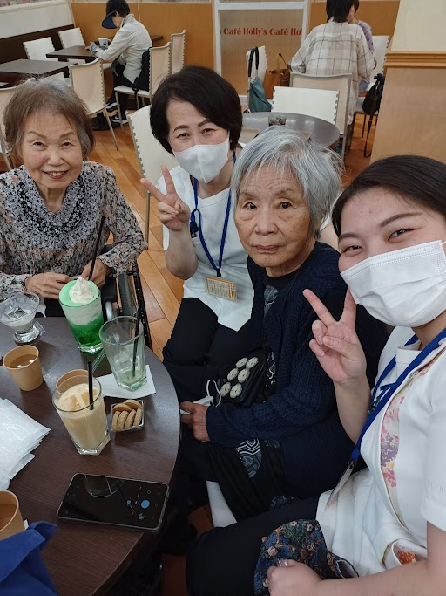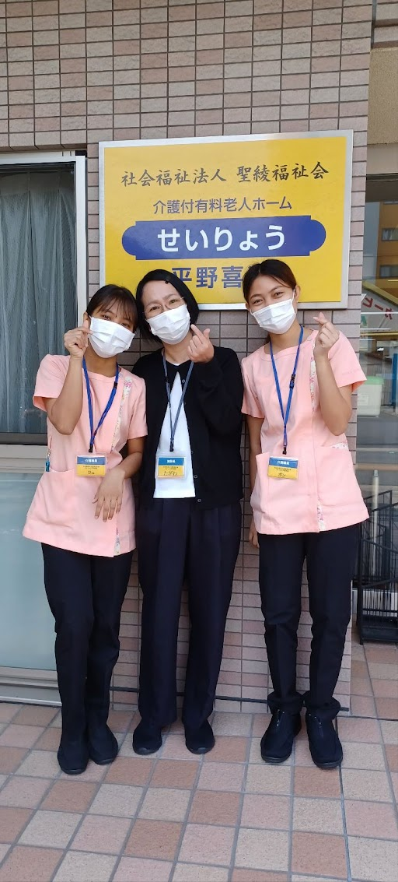

|  |  |  |  |  |
| --- | --- | --- | --- | --- |
| せいりょう平野喜連 | | | | |
| SNS更新中! | | | | |
|  | | | | |
| 日々のご様子を  　ぜひ、ご覧ください😎 | | | | |
|  | | | | |
|  | **ブログ** |  | ***Instagram*** |  |
|  |  |

